**Ask:**

Bellabeat Products smart devices are fitness health data that help gain knowledge on how customers use these devices. Our insights can help markets target a specific audience that we know our audience will be and how our marketing team will attract customers

**Prepare**

● Our Date is stored https://www.kaggle.com/arashnic/fitbit. Our data is organized by

○ Heart Rate

○ Calories_burned

○ Intensity per Hour

○ Steps Taken By HJour

○ MET-is the ratio of the rate of energy expended during an activity to the rate of energy expended

○ Sleep_day

○ Activity_Day

○ Weight_Day

● The dataset is generated from a survey Via Amazon Mechanical Turk , where 33 users were given consent to track their data.

● The data is Cited from A fitBit is a very reliable source

Process

The Tools that I will be using are SQL for analyzing the data, and Tableau for visualizations for the data.

# We want to get the average calories per day

SELECT AVG(Calories) AS AverageCalories, FORMAT_DATE('%A',ActivityDay) As Day FROM `delta-sanctum-331816.Bellabeat.Daily Calories`

GROUP BY Day

#To check how many users in this database

SELECT DISTINCT ID

FROM `delta-sanctum-331816.Bellabeat.Daly Activity` LIMIT 1000

#To see the average of minutes and distance the users run SELECT FORMAT_DATE('%A',ActivityDay) As Day,

Avg(LightlyActiveMinutes) AS LightAvgMinutes,

AVG(FairlyActiveMinutes) AS FairlyActiveMinutes,

AVG(VeryActiveMinutes) AS VeryActiveMinutes,

AVG(LightActiveDistance) AS LightDistance,

AVG(ModeratelyActiveDistance) As ModeratelyActiveDistance, AVG(VeryActiveDistance) As VeryActiveDistance

FROM `delta-sanctum-331816.Bellabeat.Daily Intenesities`

GROUP BY DAY

SELECT cast(ActivityHour as time) As Time, AVG(TotalIntensity) AS Intensity FROM `delta-sanctum-331816.Bellabeat.Hourly Intensities`

group by time

Share

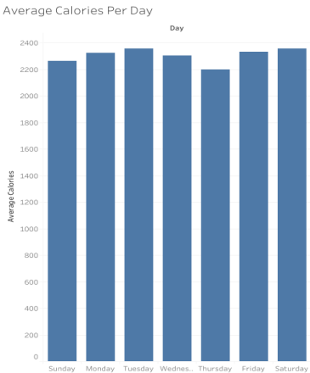

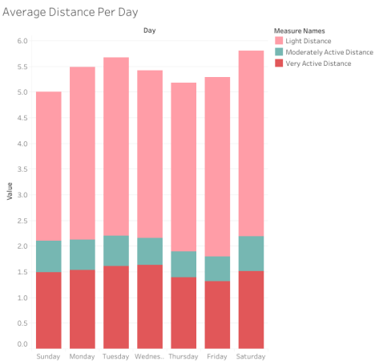

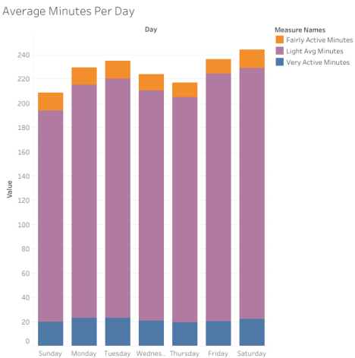

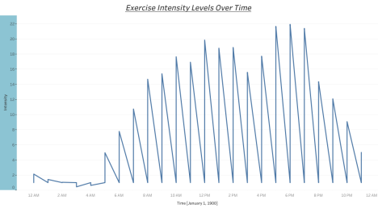

ACT

Executive Summary

Key Finding- There are only 33 users in this Dataset, which is very small . The dataset is only for one month.

● Recommendation. To make this dataset more accurate you need to make the dataset longer. Which mean more users fom BellaBeat from Fitbit

Key Finding-Participants were the most active on Saturday which led to the largest distance they were active. The least active was on Sunday which lead to least distance they were active

● Recommendation-Although Sunday is a rest day where they have no work. It is best to send a notification to get them to reach their required goal for active minutes. Then congratulate when they reach their goal

KeyFinding- Participants had a high level Intensities working out between 6pm-8pm. Those times are probably when they are off from work and had a free time to do physical activity.

● Recommendation- Make a notification to show how much your heart beat is beating, also how much your calories you are doing when your physical intensity goes up. Make an alert when you reach a certain intensity so you can keep track of what activity, can you help you burn more calories.